Kalamazoo American Chemical Society Spring Tour Speaker
Kalamazoo Area Math & Science Center (KAMSC)
6:30-8:00 pm, Tuesday, Mar 22, 2011

Professor and past (1994) ACS President Ned Heindel of Lehigh University gave a presentation to about 10 members and 40 high school students entitled "Tinctures, Tonics, and Patent Medicines: A History of Commercialized Quackery." This was the second of three presentations that Dr. Heindel gave in our region as he traveled through on his way to the National ACS Meeting in Anaheim (Mar 26-31).

During his day in Kalamazoo, Dr. Heindel received tours at Kalexsyn, Inc. (Bob Gadwood and Michael J. Melnick) and Kalsec, Inc. (David Bolliet and Doug Williams). He was joined for dinner by Dr. Lydia Hines, David Bolliet and former Heindel-student Jeff Leiby. A telephone interview with Dr. Heindel by Gordon Evans of NPR-affiliate WMUK was broadcast on the morning of the presentation.

We did not have refreshments for this event but Dr. Joe Thorstenson was instrumental in mobilizing his KAMSC chemistry classes to come out to hear the talk. Dr. Heindel enjoyed the young audience members and finished his presentation by quizzing the back row of the audience.

Dr. Heindel’s presentation was advertised on the campuses of Western Michigan University, Kalamazoo College and Kalamazoo Valley Community College as well as various local member companies and the KACS web site. Dr. Lydia Hines provided advertisements to all local section high schools and listed the event on the Kalamazoo Gazette and WMUK radio community calendars. A phone interview with Dr. Heindel was broadcast on WMUK radio on the morning of his presentation.

The flyer for the talk is attached below.

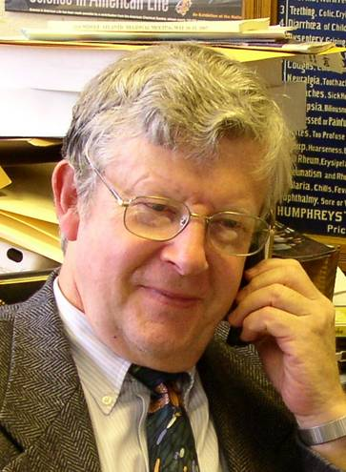
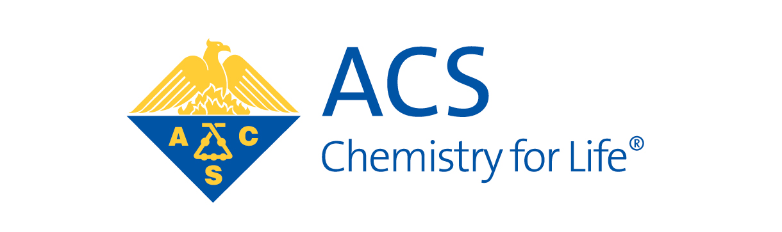

Tinctures, Tonics, and Patent Medicines:
A History of Commercialized Quackery

6:30 pm, Tuesday, March 22

4th Floor Presentation Center
Kalamazoo Area Math & Science Center
600 W. Vine Street, Kalamazoo

Park in the lot in back of the building and enter through the Dutton Street entrance

While folk medicines and natural product derivatives have, in many cases, proven a fruitful source of modern, medically accepted therapeutics, they have also proven an abundant source for quackery. From Dr. Bateman's Pectoral Drops, recommended for "rheumatism, afflictions of the stone, gravel agues, the hysterics", to Munyon's Miracle Kidney Cure, which was claimed to "cure Bright's disease, all urinary problems, and pain in the back and groins from kidney diseases", the 19th century witnessed nearly unbelievable excesses in pharmaceutical advertising. Beginning in colonial America and extending to the passage of the Pure Food and Drug Act, a plethora of quack pharmaceutical manufacturers produced and aggressively marketed home remedies of dubious origin and questionable chemical purity. Whether the ingredients were opium and ethanol or simple milk sugar, no regulations governed their manufacture or sale. Dr. Heindel will trace the birth of America's patent medicine industry in the late 18th century and its heyday of unregulated commercial success in the 19th century. The role of chemistry in the production, analysis, and eventual legal regulation of patent medicines will also be treated.

Dr. Heindel is the Howard S. Bunn Professor of Chemistry at Lehigh University and a past President of the American Chemical Society (1994).

